From: Tamerton Foliot Village Conservation Society (villageconsoc.tamertonfoliot@gmail.com )

“Protecting our Village” Website: www.tfvcs.org.
23rd September 2026 TFVCS 71st newsletter
We are GDPR compliant. If you don’t want to receive the newsletter e mails, please let us know - also, if there is anyone you know of who would like to be added to the list, again please let us know.

MacMillan Coffee morning at the Chapel, Fore St c/o Ian and Debbie Tanner. £3 to include coffee. SATURDAY 26th Sept 1030- 1300

TFVCS AGM

Our AGM is Friday 23rd October at 7pm in the Parish Hall. Official business takes around ¾ hour followed by Q&A followed by refreshment and then, our speaker is Richard Stevens who is the Managing Director of Plymouth Citybus. The subject is the all-inclusive title of “Running a bus company”
(PS If you would like to be considered to join our committee, please let me know (in confidence) on our e mail – per top of this letter)

Noise and Speeding on Fore St/ Whitsoncross Lane
Recent Facebook extract: ”Sorry to complain there was a car or motorbike last night drive up and down all night speeding up the hill on fore street at 2 o’clock in the morning non-stop if you’re that bored drive up on Dartmoor some us are trying to sleep am sorry fore street is not a racing track”
We agree with this complaint from a nuisance and a safety point of view, The following will be of interest to people looking for action on this.
What is Community Speed Watch (CSW)?
Community Speed Watch (CSW) is a national initiative where proactive members of local communities are trained by the police to record details of speeding vehicles using handheld speed detection equipment. Speed Watch monitoring sessions are undertaken at sites located within 20, 30 and 40mph areas only. Prior to use, each site has been individually assessed by trained police staff to ensure it meets our safety standards for that location.
Volunteers are highly visible to passing motorists to encourage drivers to be more speed aware when driving through the location.
Registered keepers of vehicles recorded exceeding the speed limit are contacted – initially with a letter – explaining the potential risks and consequences of their dangerous behaviour. Repeat offenders may receive a visit from local police. Collated evidence of continual excessive speeding will lead to more focused enforcement and criminal prosecutions.
https://roadsafety.devon-cornwall.police.uk/community-speed-watch-csw/

St Mary’s Roof Appeal

Our only listed Grade 2* building In Tamerton Foliot (the others are Grade 2) is desperately in need of repairs to the roof. As builders will know, ‘watertight’ is the first consideration for a building, even more than subsidence. St Mary’s roof was never perfect after the fire destroyed it in 1981 and lead was thieved from part of it in around 2018. Quotes to complete work on the roof and repair internal damage total £40,000.
Your Conservation Society has made a grant of £600 towards this. The Parish Council has applied for grants from a number of sources and it helps greatly to show these funders that the community is doing something to help. If you would like to add your own contribution to support the Church fabric, the account is
PCC of Tamerton Foliot; 30-96-68; a/c 00503131
giving ROOF followed by your surname as the reference.
If your gift is over £30, then please send a Gift Aid declaration to phil.sloggett.treasurer@gmail.com with the words
“I want to Gift Aid my donation to St Mary’s Church roof appeal. I am a UK taxpayer and understand that if I pay less income tax/ and or capital gains tax in the current year than the amount of Gift Aid claimed on all my donations it is my responsibility to pay any difference,” and your name, address and date.
Cann House Corner
Traffic calming measures have helped BUT only for observant drivers. One speeding drunk driver hit the hedge when the temporary roadworks were present. Also, the 20mph road sign has been hit by a large vehicle.

Piggy Alley Lane
Readers may know this short cut from the bottom of Whitsoncross Lane to Horsham Lane. It is being fouled not only by litter but by coloured plastic bags containing what we don’t want to describe. This is also, I see from Facebook, a fairly common complaint at the top end of the village as well. If readers wish to make suggestions for better ‘bin’ arrangements, we will attempt to co-ordinate them and put them to the Council.
Knotweed
A reader alerted us some months ago to the knotweed (which is now flowering) behind the gas pumping station at the start of Riverside Walk. We have enquired with PCC – and the land is not theirs. The utilities company (Wales and West) say it is not theirs. The search continues!
Bat Walk Friday 9th October. – 6.15 pm to 8pm
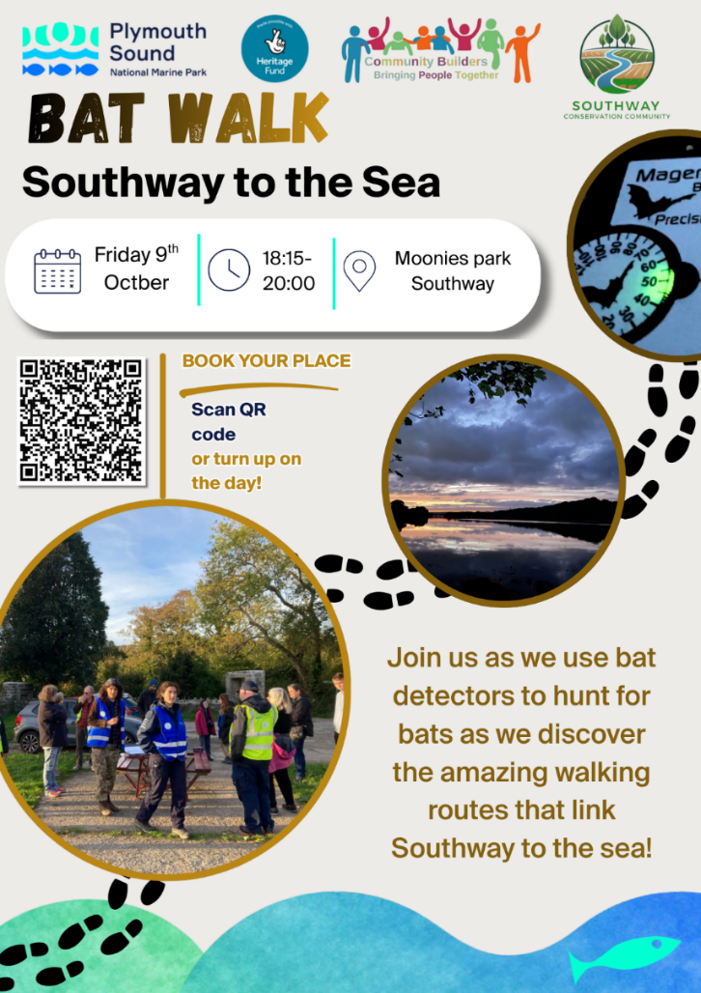

Moonies Park is the playground behind 37, Frontfield Crescent and also accessible from the downhill Southway Drive.

Forthcoming traffic survey.
Readers will be aware that we conducted a traffic survey in 2025 at the Horsham Lane/ Fore St roundabout on Thursday 20th, Tuesday 25th and Thursday 27th November. The results were presented at a reception at the Seven Stars in December – which turned out to be a good social occasion as well. Data collected puts us in a powerful position with respect to proposed future developments and their impact on traffic through the village. We look to replicate the survey this year on dates towards the end of November and will be calling for volunteers in due course.
Environmental Impact Assessment (EIA) screening (26/01022/ERS103).
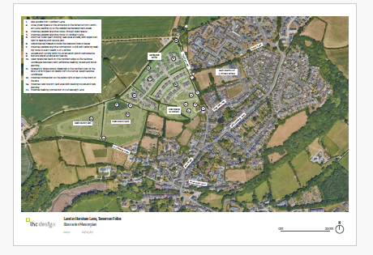
Plymouth City Council have recently been responding to a request for advice from the applicants to develop 75 houses to the West of Horsham Lane. The proposed development is approx. 35 acres and so falls into the scope of an EIA – a separate process from the normal planning route. PCC have agreed with the applicant that this is not required. PCC point out that only 20% of large schemes fall into this category – schemes such as the relief road, Platinum Way. We concur (in this instance) but are assured by PCC that the planning process will be rigorous and will account for the multiple concerns which we have already expressed.
Our stance on this application is to oppose – unless it can be clearly seen that the development is in the best interests of the whole village and not simply a part of meeting building quotas and providing developer gains.

Strategic and Local Government Re-organisation
Readers may know that the proposal for a Greater Plymouth to (incorporate 13 local parishes) has been suspended as a result of countrywide objections to similar schemes.
Additionally, Plymouth is to make a decision on whether to join the Devon and Torbay Combined County Authority (DTCCA) which would then lead to a combined population of 1.2 million and have powers over transport, education, housing, adult skills. All would be under the control of a directly elected mayor.
[I must admit that my head is hurting while contemplating all this and I personally just see layer on layer of local government still dependent on funding from central government. If there are any revelations, I will attempt to let you know.]

Meanwhile…please do support TFVCS at our AGM – Friday 23rd October 7PM!

Yours sincerely
Dennis Silverwood
for Tamerton Foliot Village Conservation Society

