From: Tamerton Foliot Village Conservation Society (villageconsoc.tamertonfoliot@gmail.com )

“Protecting our Village” Website: www.tfvcs.org.
1st June 2026 TFVCS 70th newsletter
We are GDPR compliant. If you don’t want to receive the newsletter e mails, please let us know - also, if there is anyone you know of who would like to be added to the list, again please let us know.

Mary Dean’s Avenue – proposal to build up to 6 houses (25/00575/PIP) – Appeal dismissed
Residents will be relieved to know that the Appeal made on behalf of the landowner has been dismissed by the Planning Inspectorate (12th May). Plymouth City Council have consistently refused planning and opposed the appeal. Back in May 2025, there were 139 personal letters of objection and a photo-op and news item.
The inspector dismissed the appeal on the grounds that the area is a public amenity. He comments that he saw signs of use by children when he visited in April. The issue of traffic did not carry a great deal of weight. The Inspector points out that the landowner (Manchester based Maltford Ltd) may choose to fence the area – up to 1 m high by the road and up to 2m high around the sides. Residents may wish to take note.
Post Office
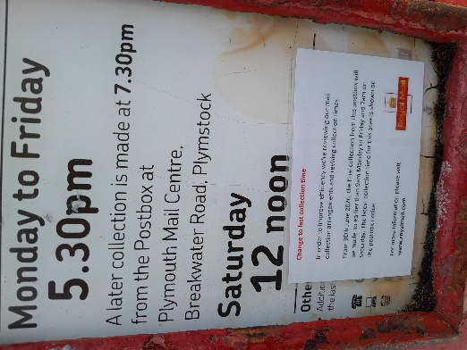
We imagine that everyone will by now know of the sale and transfer of ownership of the village stores and the closure of the post office to take effect 30th June. There has been praise for the outgoing postmaster Paul Butler who has run the shop for 16 years proving a great service to the community. The PO trade has been declining over many years, mainly due to increasing use and reliance of people on online services and has become economically unviable.
In common with many people, we feel that the closure of the PO removes yet another hub for the community to ‘bump into’ one another as well as depriving people of the remaining services such as acting as a banking hub.

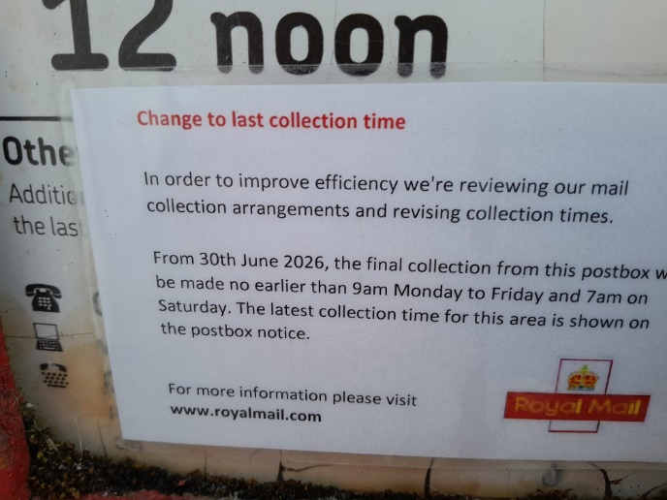
The POST BOX will remain in use…but please note the following new label stuck on the collection schedule.
“ The final collection from this postbox will be made no earlier than 9am…etc”
This equates to saying “It can be any time later than 9am – our choice – but if you want to be sure, get your mail in the postbox by 9am” and this roughly means “Last collection (guaranteed) is 9am, contrasting with 5.30 as now.”
Therefore, if you drop a 1st class letter into the postbox at 9.05, it could be 32 hours before it is even collected let alone delivered.
We will be writing to Fred Thomas MP to join the body of those others who have already expressed their concern.

Website ‘scraping’
From time to time, our website www.tfvcs.org runs very slowly. Our web manager tells us that this is due to AI bots downloading the complete website in order to ‘train’ themselves. This happens 2 or 3 times a week for periods of 1 or 2 hours.
Carnival
We understand that the carnival was a financial success as well as being a good day for all. As always, out congratulations to the carnival team.
Our stand at the carnival 9th May was moderately well patronised given that we were not running our usual bottle stall. The point is that people who came along were interested in TFVCS rather than winning a bottle.
We presented our first draft of VISION for Tamerton Foliot’s future and received almost unanimous support (certainly no objections). More of this below under Plymouth Plan.

South West Water visit
This is a summary of the visit on 7th May to TFVCS by the Asset manager of South Devon and the local operations manager. Both are highly knowledgeable and carry total responsibility for WASTE WATER management in the area.
The picture shows sewage overspill running down Church Row Lane (9th dec 2025)
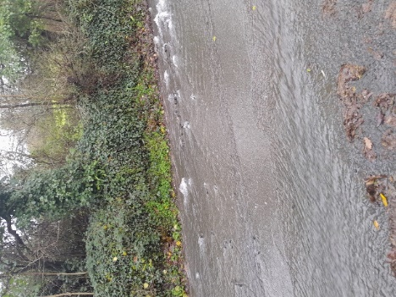
In essence, the sewers are not blocked or inhibited but, as everyone can guess, suffer from a big demand from surface water run off during intense rainy periods. Some of this is because developers have misconnected to foul water sewers (rather than piping to the stream); other contributions are from broken pipes and surprisingly from Woolwell pumping over the watershed into the Coombe valley sewers. There have also been problems with the holding tank half way along Coombe Lane. SWW have a programme of investigation (cameras) into the network and, we are told, have a budget for remedial work. From the discussion, we expect a much better situation within 2 years.
We are grateful to SWW for their genuine engagement with us.
Full notes are on our website www.tfvcs.org
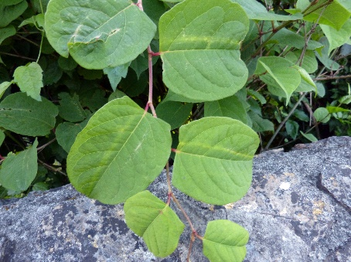
Knotweed
We have been re-alerted to the existence a small area of knotweed at the entrance to Riverside Walk and have written to the supposed landowner (Wales and West Utilities). We will follow this with the Environment Agency and City Council if there is no response.
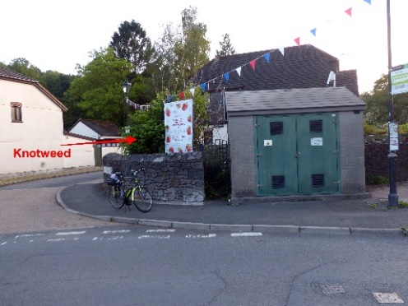
In summary, it is not illegal or even notifiable to have Japanese knotweed on your land BUT you must not let it spread from your land (e.g. cutting it and putting into the council’s bins). You can be prosecuted if you do allow knotweed to affect other’s land and so the best thing to do is to get rid of it rather than be complacent that it will not spread.

Plymouth Plan
Quoting from PCC “We want a Local Plan that reflects the hopes, ambitions and everyday experiences of the people who live here. Plymouth is changing – through new homes, new industries, and major investment and we want residents shaping a city that works for them”
Because the government is still havering about the Local Government Re-organisation (consultation finished 26th March), PCC planners cannot begin economic/ spatial planning for an area which they may or may not be responsible for. PCC will therefore engage with communities on their VISION for Plymouth and their area.
So, here is what TFVCS has put forward and tested at the Carnival. We will adapt it according to views received from you.
What do you think of these vision statements for the future of village?
 |  | Agree | Disagree | Not sure
1 | As a unique and historical village
2 | In its own ‘green’ setting separated from urban development
3 | Accessible and well connected to country walking routes
4 | A semi-rural community with good facilities and public transport
5 | An extended Conservation Area to protect the village

Please provide your thoughts about the vision and the future of the village over the next 20 years. You may for example think that we should become a planned residential area with more development and infrastructure. Let’s see.

Traffic Survey (repeat)
Following our successful and informative traffic survey in the village last November, we are considering a similar survey in early July. This will complement the winter results and strengthen our understanding of why ANY developments in or around the village cannot aggravate the situation. We will be in touch for volunteers should this be feasible.
AGM date
Our 2026 AGM is Friday 23rd October in the church hall. Time to be advised. Do put the date in your diary and come along.

Yours sincerely
Dennis Silverwood
for TFVCS

