From: Tamerton Foliot Village Conservation Society (villageconsoc.tamertonfoliot@gmail.com )
“Protecting our Village”
18th May 2022 TFVCS 58th newsletter
We are GDPR compliant. If you don’t want to receive the newsletter e mails, please let us know…also, if there is anyone you know of who would like to be added to the list, again please let us know.

Community Litter Pick – this Sunday 22nd May - 1030
Wadlands Meadow. Organised by the Carnival Committee. All volunteers welcome. Bags/ tools/ removal provided.

Application to build 14 houses - fields by Cann Lodge/ Cheshire Drive - Appeal refusal
20/00704/OUT.
This application was submitted in 2020 by Trustees of the P D Tuckett Will Trust and refused by Plymouth City Council in August of that year. The Applicant then appealed against the refusal in October 2021 and this was refused by the government inspectorate. It is interesting that although there were many reasons against building there, the balance was tipped by a) it is in a conservation area and b) the city has its provision for housing earmarked through the JLP and this site is not included. However, there are signs that the government wishes to have the ‘buffer’ of housing sites increased to 35% of the forecast provision and this is likely to raise the issue again.

Tamar valley crematorium
Out last newsletter advertised the consultation on this proposal to build at a site adjacent to Haxter Lodge (where Roborough lane turns east towards the Plessey roundabout). Application for full permission to build this has now gone in to South Hams planners and will appear on their website in the near future.
Our main interest has been to provide a path through the site to the National Park in order to avoid the unpleasant stretch of road for walkers between the Plessey roundabout and Green Café (Dartmoor Diner).
MAY CARNIVAL – 7th May
Anyone who attended this year’s carnival will have seen what a great success it was. We have not had the figures verified but there were 58 stalls and attractions and over 1000 people throughout the day. The shop and the pubs did a roaring trade and the only untoward incident that we have heard of was the disgraceful theft of one of the raffle prizes – a bottle of wine, found with the culprit under a nearby hedge.
There were displays by dancers, karate exponents, morris dancers, samba band and a dog show. The parade down from the top of the village was scheduled to begin after the 1219 bus has left – but the bus was late and eventually passed the parade at the bottom of the village on its (the bus’s) way up.
The Committee have made a donation towards the maintenance of the defibrillator mounted at the Queens Arms.
Brilliant. Well done to the committee.

Strawberry Fair - Saturday 25th June in St Mary’s Church hall
This follows the tradition dating from when the village was the centre of a horticultural industry in common with much of the Tamar Valley. It is an opportunity for a get-together over tea, cream and of course, strawberries. Look out for the posters.

TFVCS AGM
Our AGM was held in St Mary’s church hall on Friday 25th March. Attendance was 27 plus 5 committee with 11 apologies (the chairman was one of these – Covid!). The Committee of 6 were elected en bloc presided over by a former chairman of TFVCS, Tony Kirk. The speaker was the Head of Water Quality from South West Water who talked about the Mayflower treatment works (the one you can see on the skyline from the road up to the Dartmoor Diner). This is one of the most advanced plants in the world being the first SIX/ILCA/CeraMac installation.

New saplings
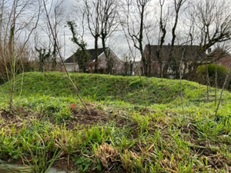
The saplings planted by Taylor Wimpey on the bund at the top of Whitsoncross lane are disguised by the long grass. However, the hawthorn, hazel and field maple are surviving and we hope this may restore something like the view before the Copleston Heights estate was built and provide a bit more wildlife thoroughfare.

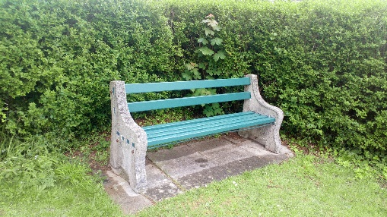
The ‘Annington’ seat.
The seat by the bus stop at the top of Whitsoncross lane has been refurbished by TFVCS. It was initially donated by Annington Homes who took over the old naval estate in (Year? – any information welcomed).

Photography post in Wadlands meadow.
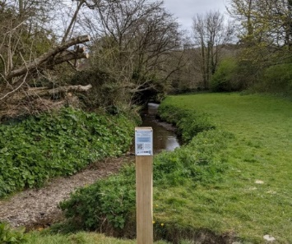
Plymouth River Keepers asked people to use this post as a guide to send photos which they can then use to plot the development of the stream over time (erosion, tree growth, water conditions etc). The post lasted one day in position and was found a few days later in the wilded play park.
It will be replaced with a more substantial footing.

Website
Our new website went live on 7th March. This is a superb stage for the village – gallery, history, old photos, walks, local information, Plymouth river keepers, events.
Do have a look – www.tfvcs.org

Next meeting
Our next TFVCS committee meeting is Monday 20th June. Any items – please advise villagecosoc.tamertonfoliot@gmail.com

Yours sincerely
Dennis Silverwood
for Tamerton Foliot Village Conservation Society

