From: Tamerton Foliot Village Conservation Society (villageconsoc.tamertonfoliot@gmail.com )
“Protecting our Village”
10th February 2022 TFVCS 57th newsletter
We are GDPR compliant. If you don’t want to receive the newsletter e mails, please let us know…also, if there is anyone you know of who would like to be added to the list, again please let us know.

TFVCS President
The Reverend David Gill, vicar at St Mary’s for the past 16 years had his last service at the church on 30 Jan. It was a well-attended event with bring and share lunch afterwards. David and Fenny are retiring back to their home near Exeter. David has been ex officio President of the Conservation Society amongst his many other roles. We are pleased to say that Tony Kirk has now agreed to take on the role of president. Tony has been a local councillor and also Chairman of the TFVCS committee.

MAY CARNIVAL
Saturday 12th February
May Queen Choosing in St Mary’s Church hall. Forms available from Mary Dean School Reception
Wednesday 4th May
Combined choir concert of Mary Dean School Choir and St Mary’s Church Choir
Saturday 7th May – Carnival Day
This year’s theme: Kings & Queens
Saturday 25th June
Strawberry Fair in St Mary’s Church hall
Contact us at: tamerton-foliot-carnival@hotmail.co.uk
AGM
Our AGM will be in St Mary’s church hall at 1930 on Friday 25th March. Please put this in your diary and come along. Our speaker will be the Head of Water Quality from South West Water who will talk about the Mayflower treatment works (the one you can see on the skyline from the road up to the Dartmoor Diner). This is one of the most advanced plants in the world being the first SIX/ILCA/CeraMac installation. All will be explained.

Dartmoor National Park – Dogs Bye-law
A new bye-law is proposed, and amongst several others, that dogs should be kept on a short lead from 1st March to 1st August while in DNP. The full text is below.
“Proposed. 10 Dogs (i) No person in charge of any dog shall permit any dog to disturb or worry any stock or wildlife or cause any nuisance or annoyance to any person on the Access Land. (ii) No person in charge of any dog shall cause or allow a dog to be exercised other than under close control and, if directed to do so by a Ranger, must keep any dog on a lead. (iii) Between 1 March and 31 July each year all dogs have to be kept on a short lead of no more than 2 metres in length (iv) No single person shall bring more than 6 dogs on to the Access Land at any one time. “Dog” shall exclude police dogs, search and rescue dogs, guide or assistance dogs and any dog that is working on the Access Land with the consent of the landowner”
There have been 4000 comments on the various bye laws – I don’t know how many relate to the dogs. Local comment here in Tamerton Foliot is that it is a minority of people who do not control their dogs.
The consultation is now closed but can be viewed at
www.dartmoor.gov.uk/about-us/who-we-are/byelaws-consultation

New saplings
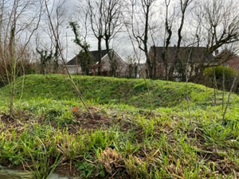
Taylor Wimpey have at last arranged for the bund at the junction of Roborough lane and Whitsoncross Lane to be planted. We hope this may restore something like the view before the Copleston Heights estate was built and provide a bit more wildlife thoroughfare.
Frank Clemens (of Frank’s Lane) has also put dropped kerbs at this point onto the council’s list through Cllr Mark Deacon but It will be a minimum of 12 months before they appear.

Tamerton Foliot First Responders
A First Responder is a volunteer who has been trained by the Ambulance Service, tasked by Ambulance Control, and attends a seriously ill or injured person in advance of the ambulance’s arrival.
Since the Tamerton Foliot First Responders was set up they have been called over 400 times to people with problems ranging from a twisted ankle to full cardiac arrest.
Ray Hall
It is with sadness that we tell you of the death of Ray Hall. Ray was Chairman of the Conservation Society in the early 90s when Tamerton Foliot was under one of the periods of severe external pressure - -the main issue was a gypsy site up the Coombe on Porsham Lane. Ray together with Barbara Bebbington and others took a deputation to Devon County Council and even to the Houses of Parliament to get this plan dismissed. He was also chairman when there was an attempt to convert Tamerton Lake (the creek) into a marina by putting a tidal dam next to Black Bridge (railway bridge). We are most grateful for his work on behalf of the village.

Website
We are intending to go live with our new website on 7th March. This is a superb stage for the village – gallery, history, old photos, walks, local information, Plymouth river keepers, events.
Do have a look – www.tfvcs.org
Proposed crematorium site
A consultation is out at www.tamarvalleycrematorium.co.uk on this site next to the Royal Mail parcel depot at Belliver/Bradley. The site benefits from a tranquil view over farmland to the Tamar Valley.
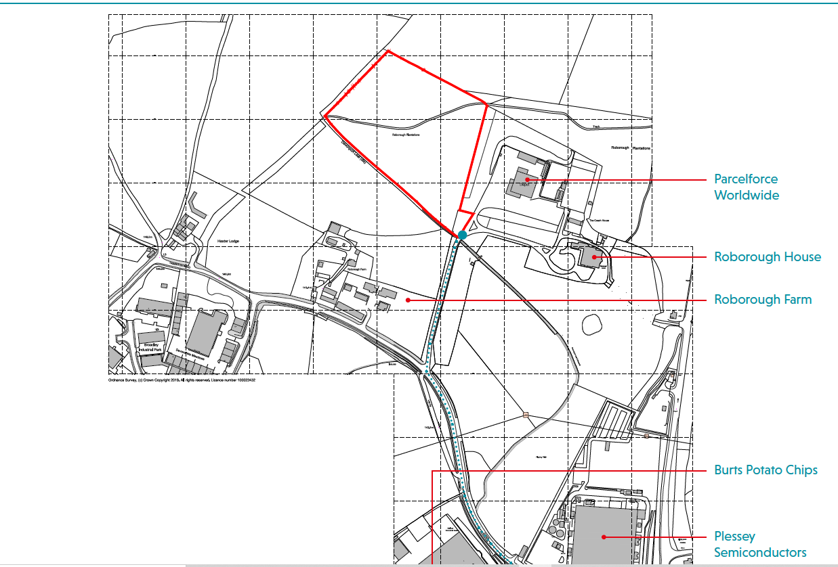

Plymouth/ West Devon/ South Hams – Climate Emergency Plan - online meeting
If you are interested in what our new Climate Emergency Planning Policy and Guidance Consultation Document means for new development, watch the Joint Local Plan Partnership Board AGM on Monday, 21 February 2022 at 11 a.m.
This is the second AGM of the Board and all elected Members from across the three Local Planning Authorities of Plymouth City Council, South Hams District Council and West Devon Borough Council have been invited. This is an opportunity for the public to learn how we are positively addressing the Climate Emergency.
If the new Planning Policy and Guidance Consultation Document is agreed by the Board there will be a 6 week public consultation to hear your views on the measures we are proposing.
This meeting will also consider the latest Monitoring Report and progress made towards the key plan indicators.
The Live Stream will be hosted by South Hams and West Devon. Please use the link below to watch
South Hams West Devon

Next meeting
Our next TFVCS committee meeting is Monday 14th March. Any items – please advise villagecosoc.tamertonfoliot@gmail.com

Yours sincerely
Dennis Silverwood
for Tamerton Foliot Village Conservation Society

